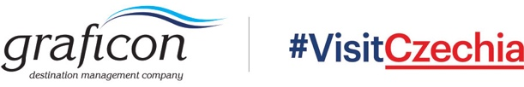

Application & Reservation Form l Riyadh Travel Fair 2023 l Riyadh, KSA: 22. – 24. 5. 2023

PARTICIPANT DETAILS:
S.NO. | NAME | DESIGNATION

COMPANY DETAILS:
Contact Address, Country:
Telephone with Area Code:

PARTICIPATION:
Please tick the selected events:
Riyadh Travel Fair 2023 (22. – 24. 5. 2023)
Networking evening in cooperation with the Embassy (most likely 25. 5. 2023)

GENERAL CONDITIONS:
The participation fee will be paid upon an invoice issued before the event by the partner of CzechTourism – Graficon DMC. Each participant will settle the payment within 14 days after invoice delivery.
The participation fee includes participation for one company at a shared table and shipment of 15 kg materials.
Participant will provide all needed company details to the organizer immediately.
Participant will arrange and cover accommodation and transportation from the Czech Republic to Saudi Arabia and back.
Participant will respect the event schedule and will be present at the venue accordingly.

CANCELLATION POLICY:
Graficon is authorized to apply 100 % cancellation fee in case the participation is cancelled after
15th April 2023.

Participation fee is 50 000 CZK without VAT

The above fee does not include bank charges. All bank charges are to be borne by the company attending the event.

Total price to be invoiced | Please fill CZK + VAT

To participate in the event please send the completed and signed form to: hani@graficon.cz

Application deadline: 31st March 2023
Herewith I confirm my participation in the “Riyadh Travel Fair 2023” and accept all above mentioned conditions.

Date:

Company stamp, Signature:

